Except famous players (like Taobao), are there any other e-commerce platforms that international brands can leverage in China?
China has the largest e-commerce market in the world and it is still keeping growth year on year. According to the China E-commerce Report, in 2017, the total value of Chinese online trading had reached 29,160 billion CYN, which occupied 40% of the global e-commerce market and up 11.7% compared with 2016. During the same period, the value of online retail reached 7180 billion CYN in China, up 32.2% compared with 2016. For the huge online retail market in China, there are more and more e-commerce platforms have been built in China, except those big players like Tianmao (天猫), Taobao (淘宝) and JD (京东), mobile e-commerce platforms such as Pinduoduo (拼多多), Xiaohongshu (小红书), Kaola.com (网易考拉) and etc are also popular among Chinese consumers. For international brands that want to enter Chinese market by e-commerce, those online shopping platforms are another kind of important channels.

Source: China E-commerce Report 2017

Pinduoduo (拼多多): The representative of online group shopping in China

Pinduoduo (拼多多) is one of the most popular e-commerce platforms among Chinese consumers. In 2015, Pinduoduo officially launched as a mobile e-commerce platform in China and became one of the fastest-growing online platforms for its new business model. According to the data from official website of Pinduoduo, by the end of 2017, the users of Pinduoduo app have exceeded 0.3 billion.
Group shopping is the main point of Pinduoduo that attracted many Chinese customers online. On Pinduoduo, customers can choose group orders for all kinds of good, then buyers can achieve relative low price. Based on group orders, the platform will make a large amount of orders directly from manufacturers and get quantity discounts from them.

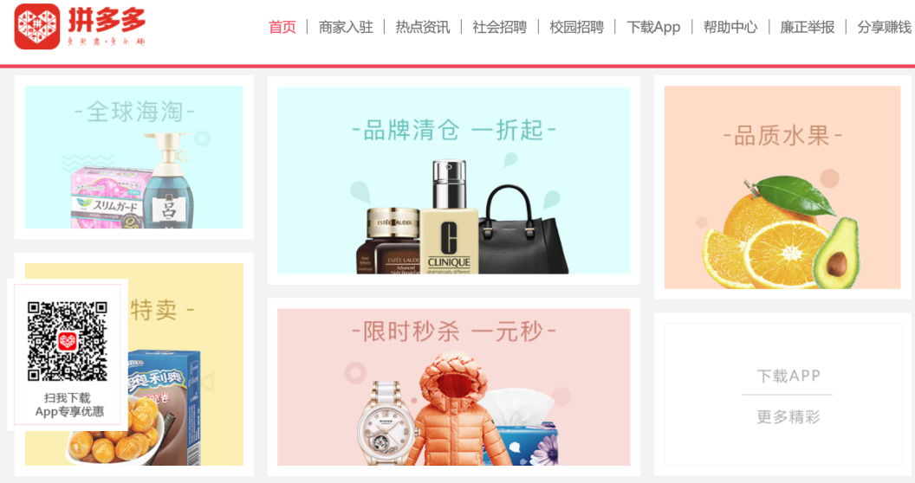

For international brands that want to open stores on Pinduoduo, there are some advantages and restrictions of the platform should be noticed:
Advantages | Restrictions
- Directly apply from the official website of Pinduoduo | - Chinese business license, tax registration certificate, organization code certificate and bank account opening license are necessary.
- Brands will be easy to get a large amount of orders after building cooperation with Pinduoduo. | - Before stores pay deposit, they are not allowed to launch products with the total value exceed 2,500 CYN on Pinduoduo.
- No deposit when open stores and launch new products that less than 2,500 CNY. | - The total amount of inventory for one product can’t more than 100 without deposit on Pinduoduo.
- Quick audit, the platform will finish auditing during 2 working days after receiving application. | - Stores are not allowed to launch more than 20 products without deposit.
- By using the same business license, tax registration and organization code certificate, brands can open more than one store on Pinduoduo, there is no restriction for number of stores. | - Stores can’t join any activities or withdraw cash from Pinduoduo without deposit.

Kaola.com (网易考拉): The leading integrated e-commerce platform in China

Kaola.com (网易考拉) is the leader among online cross-border retail platforms in China. In January 2015, Kaola.com officially launched as a cross-border e-commerce platform by NetEase. The business model of Kaolao.com is direct purchasing with self-operated, or operated by third-party merchants on the platform. According to our findings based on research from “iiMedia Research” (艾媒咨询), in 2017, Kaola.com held the largest market share (25.8%) of China’s cross-border e-commerce platforms. During the 2016, the platform was ranked first in the survey on users’ satisfaction of China cross-border e-commerce self-operating platforms. In 2018 Q1, Kaola.com kept the largest market share (26%) among China’s cross-border e-commerce platforms.

Source: 2018 Q1 China cross-border e-commerce monitoring report

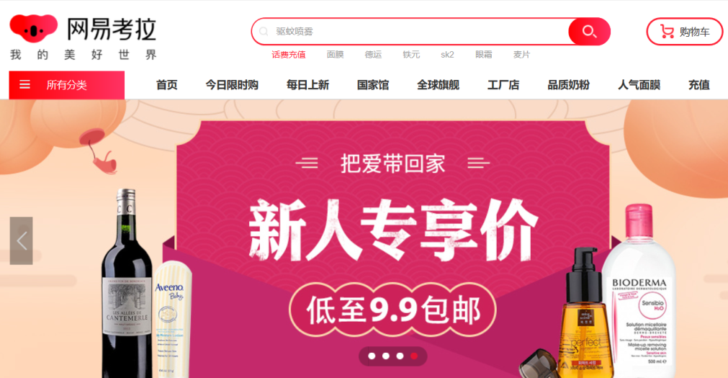

For international brands that want to enter China by e-commerce platforms, Kaolao.com has obvious advantages and a few of restrictions:

Advantages | Restrictions
- Kaola.com has a large scale of user base on the Chinese internet from NetEase. | - Brands are not allowed to directly open stores on Kaola.com.
- It is easy to promote products in China for all brands that cooperated with Kaola.com. | - Currently, Kaola.com only focus on 9 kinds of products, including Maternity & Baby, Beauty Cosmetics & Skincare, Personal Care & Home, Health & Wellness, Food & Snacks, Clothing & Shoes, Electronics & digital products, Sports & Outdoors and Fresh Food.
- Brands are easy to receive large quantities of orders after cooperating with Kaola.com.
- Kaola.com can help brands to build their credit and enlarge their influence among Chinese consumers
- Brands can achieve analysis service from Kaola.com after cooperating with the platform.

Xiaohongshu (小红书): The combination of online shopping and life-sharing community

Xiaohongshu(小红书) has became one of the most important online shopping platforms in China by combining life-sharing community and shopping. The platform was launched in 2013 and achieved first position in the App store list of China in 2015. By the end of October 2017, the number of the platform’s users already exceeded 70 million.
For most users in China, Xiaohongshu is not only a shopping platform, but also a social platform. On the platform, uses can introduce any product by using photos and communicate with other users through comments. By using the community to share the purchase and use experience, Xiaohongshu attracted many female buyers who want to satisfy vanity and get suggestions about some products.
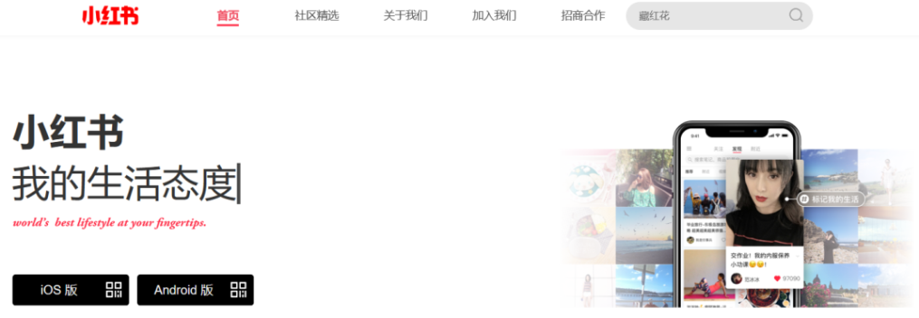

Source: Detailed analysis: Why Xiaohongshu is so popular

For international brands that want to open stores on Xiaohongshu, some advantages and restrictions of the platform should be known:

Advantages | Restrictions
- Users of Xiaohongshu are mainly consisting of female consumers, thus brands that sell female products are easy to be popular on the platform. | - Users of Xiaohongshu are mainly female consumers, which means only female products are easy to be popular on the platform.
- Through the life-sharing community, products normally easy to promote among the users of Xiaohongshu. | - The platform doesn’t accept application from retailers and traders that only sell one kind of brand.
- The cross border trading is one of main business on Xiaohongshu. | - Multiple brands must be sold in different stores.
- There is a direct guideline only for the registration of foreign brands (include Hongkong, Macao and Taiwan). | - Every dealer with official brand authorization can only open the “Single brand store” (单品牌店铺) on Xiaohongshu.
- Business registration or Certificate of incorporation is enough, Chinese certifications are not necessary.
- Sales commission is the only fee that stores need to pay on Xiaohongshu.

VIP.com (唯品会): The largest flash sale site in China and the whole world

VIP.com (唯品会) is the biggest online flash sell platform with almost 10 years history in China. The platform has pioneered the online discount retail model in China and had 57.8 million active users during the whole year of 2017. At the same time, the repurchase rate reached 84% on VIP.com. In 2018Q1, VIP.com took 12% market share of cross-border e-commerce platforms in China, which was the No.4 among all platforms. Besides, based on the data from the official website of VIP.com, the platform already owned 13,000 well-known domestic and global vendors and suppliers.

Source: VIP.com Q4 financial report

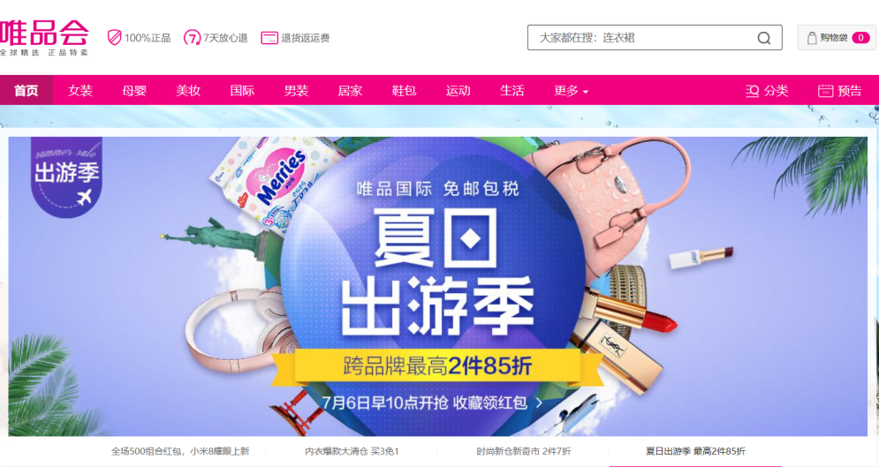
For international brands that want to become one of the platform’s partners, it’s helpful to understand some advantages and restrictions from VIP.com:

Advantages | Restrictions
- VIP.com has a large amount of users and strong brand recognition in China. | - To make sure the all products are authentic, VIP.com has strict auditing process.
- VIP.com can help brands to increase their awareness through various activities such as sponsoring profile events. | - VIP.com only accepts application from brands, official dealers, branches of brands and their office in China.
- The platform owns data statistics system and offers all relevant data to partners after sales. | - Chinese certificates are necessary, such as tax registration certificate, and organization code certificate.
- VIP.com can help brands to optimize new product development and make market strategies.
- Through professional design team, VIP.com can style brands’ products more appealing to Chinese consumers.

Suning.com (苏宁易购): The comprehensive B2C online shopping platform in China

Suning.com (苏宁易购) is one of the leading platforms in the area of China’s B2C shopping. In 2017, the net income of Suning.com was 4.21 billion CYN, up 236.52% compared with 2016. During the same year, the number of registered users reached 0.345 billion on Suning.com.

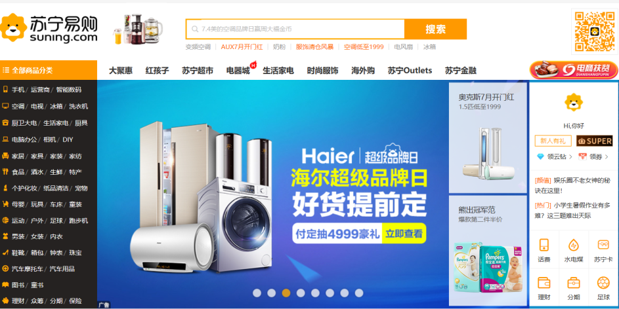

For international brands that want to opens stores on Sunung.com, it is necessary to understand its advantages and restrictions:

Advantages | Restrictions
- Extremely detailed guidance for registration and opening stores on Suning.com | - Suning.com doesn’t accept any applications from enterprises outside of mainland China.
- Three different kinds of stores can be chosen: flagship store, specialized store and franchise store. | - Suning.com doesn’t accept any applications from unofficial dealers.
- Suning.com offers marketing services and tools, such as store operations, store design and etc. | - Most services provide by the platform are paid.
- Suning.com offers advertisement solutions to stores. | - Open a YiFuBao (易付宝) account is necessary for all appliers.
- Suning.com provides financial services to stores, such as loan,
- Suning.com provides data statistics analysis services to stores.

Juanpi.com (卷皮网): One of the China’s most popular online discount shopping platforms

Juanpi.com (卷皮网) is the first domestic e-commerce platform that focus on par goods market in China. Through its unique model of “Par retail” (平价零售), Juanpi.com has become one of the largest unlisted e-commerce platform in China. Between 2016 and 2017, the number of platform’s users has exceeded 100 million and 80% of them are female. On Juanpi.com, lower price is the main point that attracts Chinese consumers, the average price of every product is around 100 CNY and 50% products come from small and medium brands.

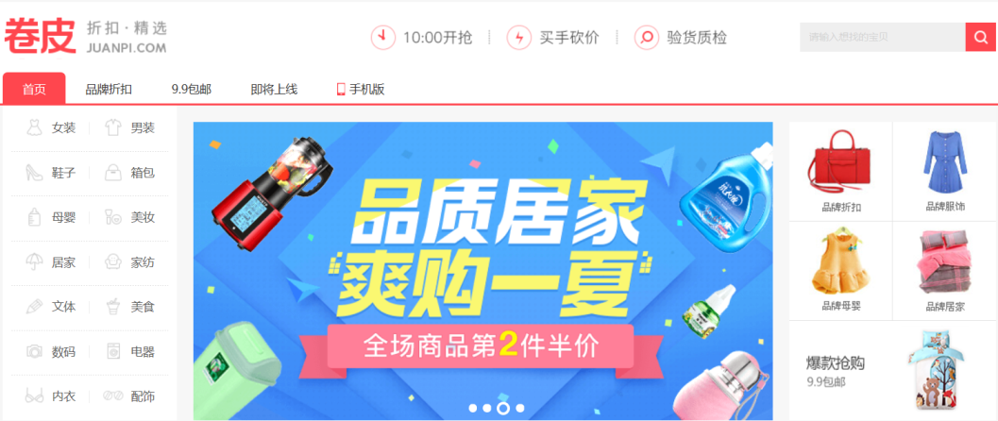

For international brands that want to opens stores on Juanpi.com, it is necessary to understand its advantages and restrictions:

Advantages | Restrictions
- Juanpi.com has high user traffic that can help brands to promote products. | - Juanpi.com doesn’t accept any applications from companies outside of mainland China.
- The platform offers loan to stores | - Except deposit, stores also have to pay technology service fee to the platform based on different kinds of products
- The platform provides subsidies to stores with good performance.
- The platform provides instant services such as professional operations service.

DangDang.com (当当网): China’s first B2C E-mall that fully based on online business and listed in USA

DangDang.com (当当网) is one of the oldest e-commerce platforms launched in 1999. The platform starts as an online book selling website and achieved 35.1% of China’s online book retail market in 2017. Now, Dangdang.com already expanded its business from books to all kinds of products. Among them, the main business focuses on book, Maternity & Baby, Beauty Cosmetics and home textiles. During 2017, the net revenue of DangDang.com was around 0.36 billion CNY.

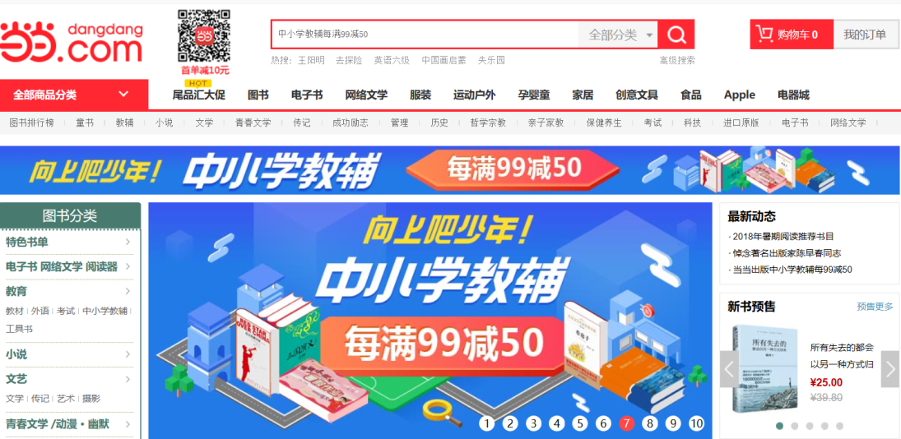

For international brands that want to open stores on DangDang.com, there are some advantages and restrictions of the platform should be noticed:

Advantages | Restrictions
- There are clear and specific conditions based on different kinds of products on DangDang.com. | - Chinese certificate are necessary such as business, license, tax registration and organization code certificate.
- DangDang.com provides various operations services to stores such as products promotion, pictures design and making marketing plan. | - The registered capital of brands can’t lower than 500 thousand.
- The platform offers inventory and supply chain solutions to stores. | - The registered time of brands can’t less than one year.
- The platform provides marketing tools and data analysis to stores. | - Except deposit, brands also have to pay technology fee and platform usage fee.

Mia.com (蜜芽): China’s first online flash sale platform for imported Maternity & Baby brands

Mia.com (蜜芽) is the largest e-commerce platform that sell imported maternity & baby products in China. Now, according to the data from official website of Mia.com, there are 1300 brands built cooperation with Mia.com and the users of the platform exceeded 30 million. On the platform, 70% products are imported from foreign countries. In the list of 2016 users’ satisfaction for China’s cross-border import e-commerce, Mia.com was ranked first among all competitors.

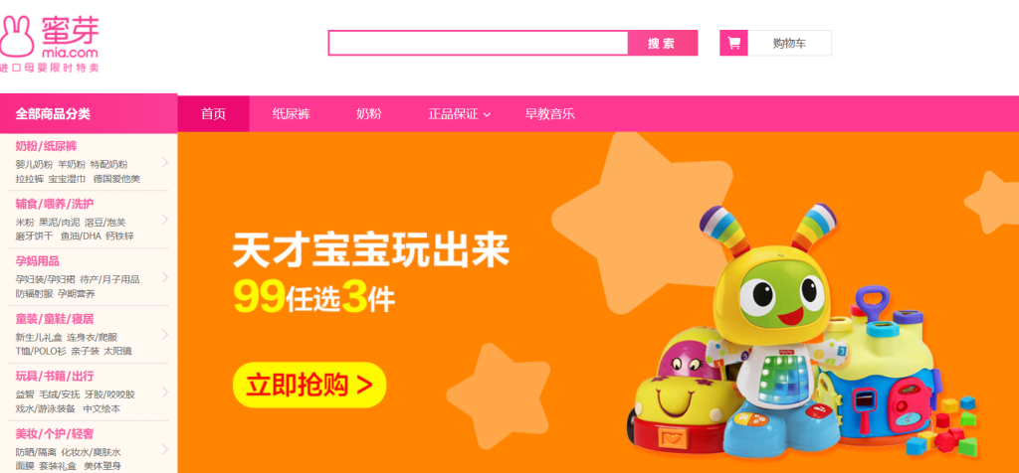

For international brands that want to become one of the partners of Mia.com, it’s helpful to understand some advantages and restrictions:

Advantages | Restrictions
- Mia.com has good reputation among Chinese customers. | - Brands can’t directly apply from the website of Mia.com, e-mail is the only way.
- Cross-border trading is the main business of the platform. | - Brands must have at least 1 year sales history.
- There are multiple ways of cooperation. | - The VAT fapiao (发票) is necessary for application
- Mia.com has two bonded warehouses in China.

China’s e-commerce platforms are good options for international brands

China’s e-commerce platform started from 1999, but there were few platforms became popular among Chinese people. Now, after 20 years development, China owned a large number of e-commerce platforms that can be divided into different types like B2B, online retail, life services, cross border and etc. For international brands that want to enter China through e-commerce platforms, through the comparison of following platforms, it is helpful to make a better option.

Name | Number of users | Revenues (CNY) | Difficulty of registration and cooperation for international brands | Expected growth trend | Evaluation (1-5 stars, 5 is the best)
Pinduoduo | 300 million | -0.525 billion | Medium difficulty | Very positive
Kaola.com |  | 11.67 billion | Easy | Positive
Xiaohongshu | 70 million |  | Very easy | Positive
VIP.com | 57.8 million | 24.1 billion | Medium difficulty | Positive
Suning.com | 345 million | 4.21 billion | Hard | Positive
Juanpi.com | 100 million | 2.5 billion | Hard | Very positive
DangDang.com | 20 million | 0.36 billion | Medium difficulty | Negative
Mia.com | 30 million |  | Very easy | Positive

China E-commerce Report 2017
China E-commerce Report 2017
2017 NetEase financial report
2016-2017 China cross-border e-commerce market report
2018 Q1 China cross-border e-commerce monitoring report
2018 Q1 China cross-border e-commerce monitoring report
Analysis of China’s publishing industry in 2017 and forecast its future trend
2016 China e-commerce users’ experience and complaint monitoring report

